Batch: D - 1 Roll No.: 16010122096

Experiment / assignment / tutorial No. 09

Grade: AA / AB / BB / BC / CC / CD /DD

**Signature of the Staff In-charge with date**

**Experiment No.:9**

|  |
| --- |
| **TITLE: Study and configure DHCP & DNS protocol using Cisco Packet tracer** |

**AIM:** To study and configure **DHCP/DNS** protocol using Cisco Packet tracer

**_____________________________________________________________________________**

**Expected Outcome of Experiment:**

**CO:**

**_____________________________________________________________________________**

**Books/ Journals/ Websites referred:**

1. A. S. Tanenbaum, “Computer Networks”, Pearson Education, Fourth Edition
2. B. A. Forouzan, “Data Communications and Networking”, TMH, Fourth Edition

_____________________________________________________________________________

**Pre Lab/ Prior Concepts:**

IPv4 Addressing, Subnetting, Link State Protocol, Router configuration Commands

**_____________________________________________________________________________**

**New Concepts to be learned: DHCP/DNS** Protocol and its configuration.

**_____________________________________________________________________________**

**IMPLEMENTATION:**

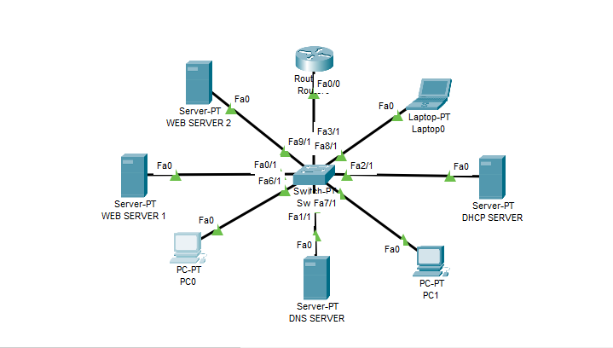

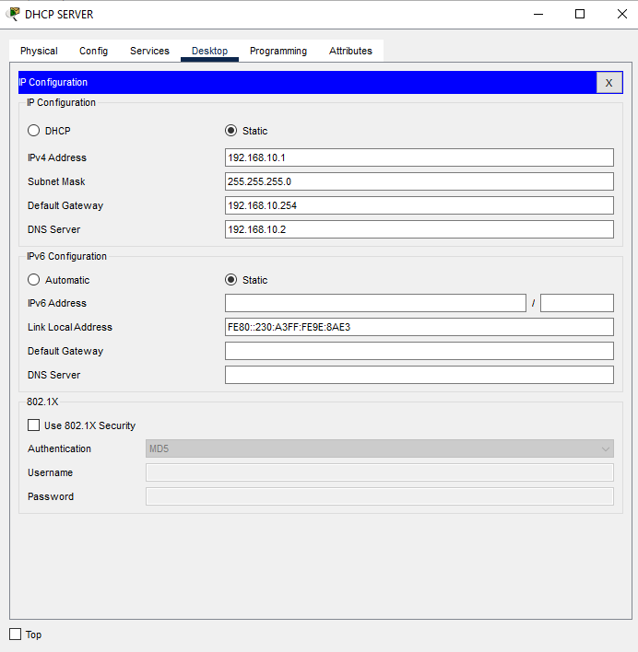

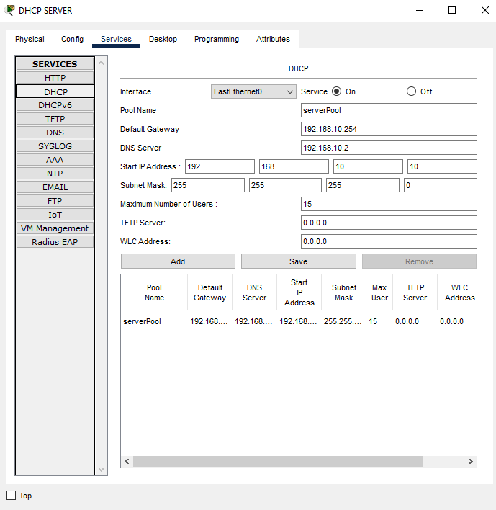

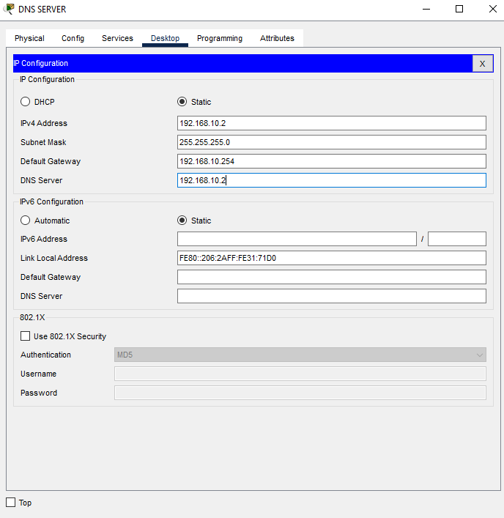

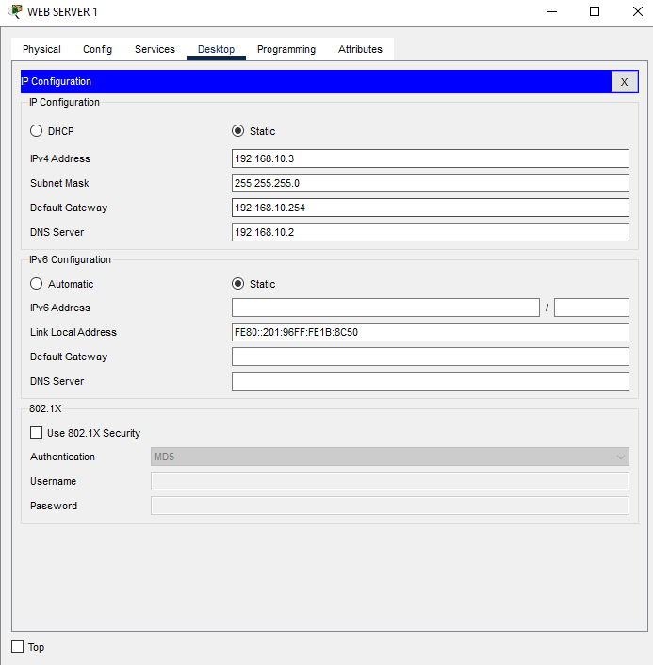

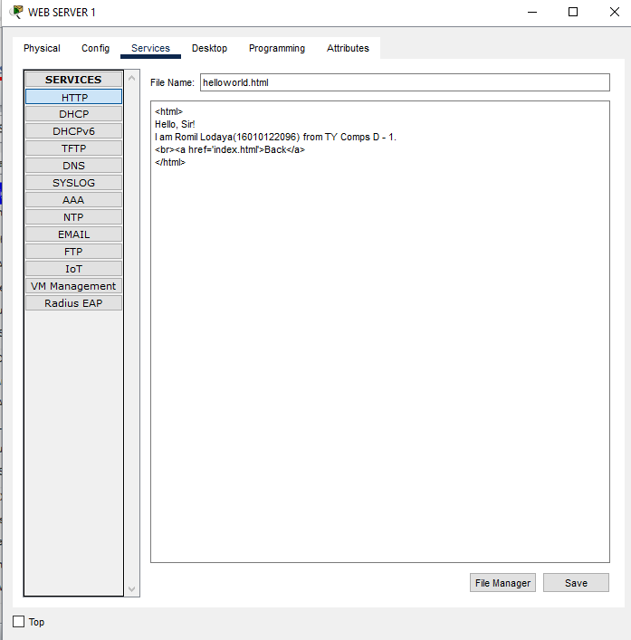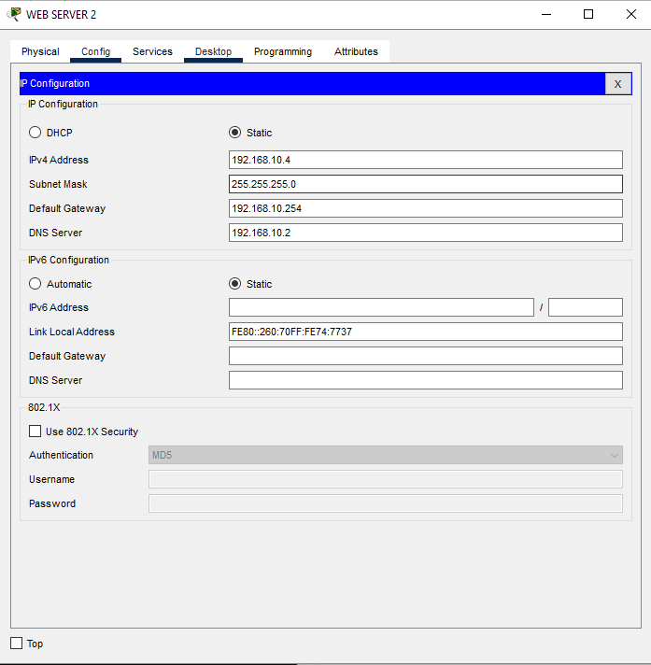

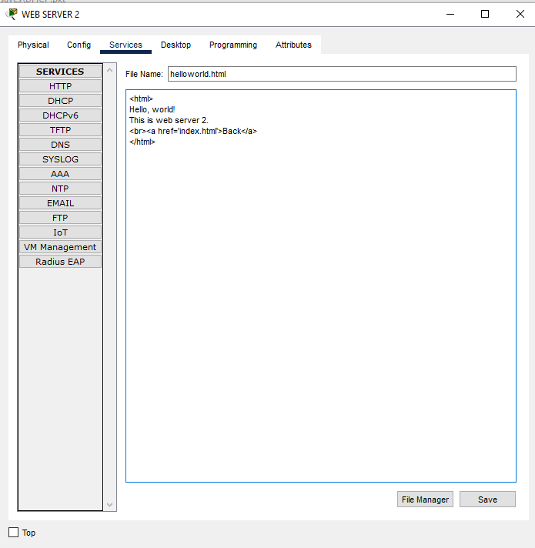

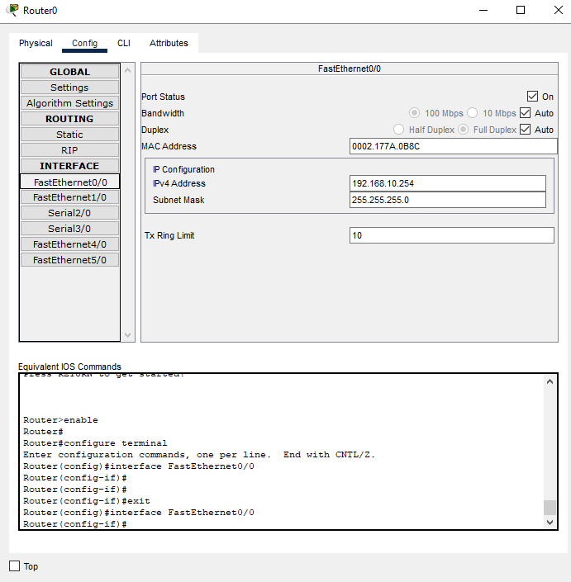

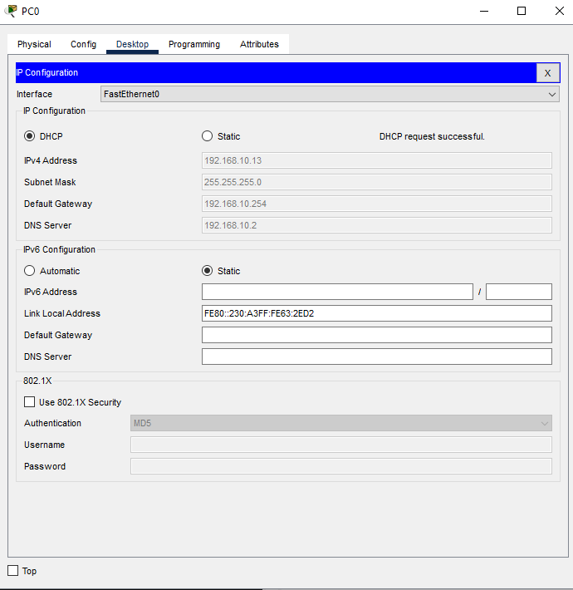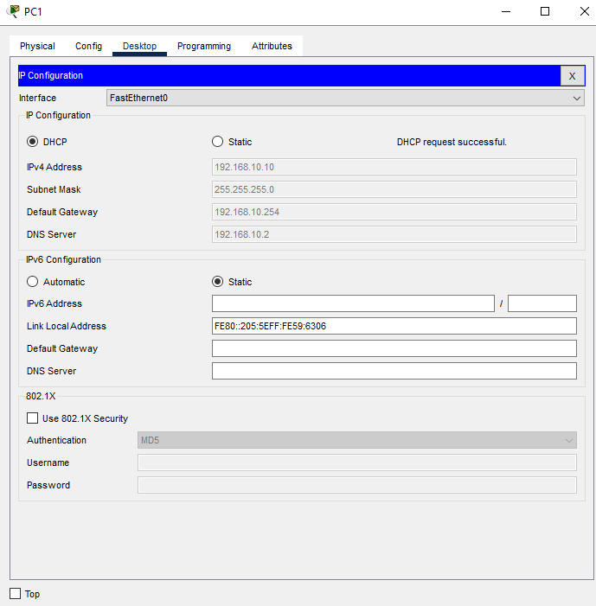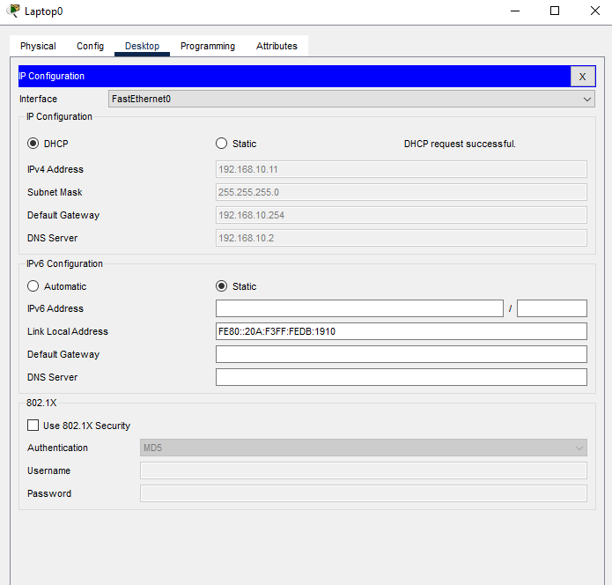

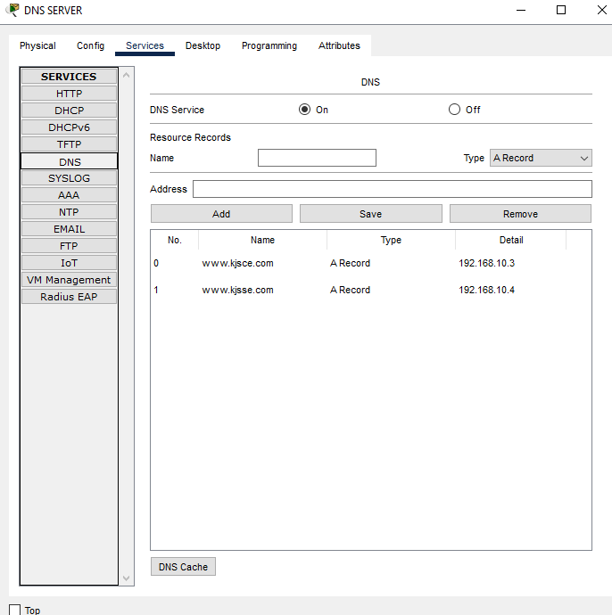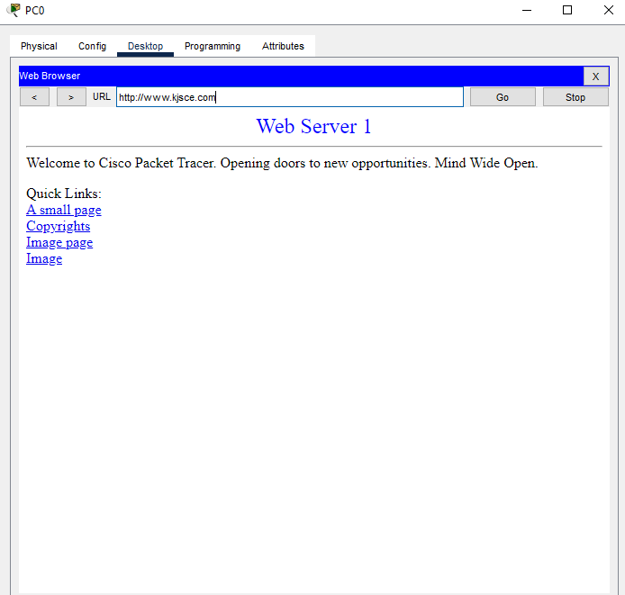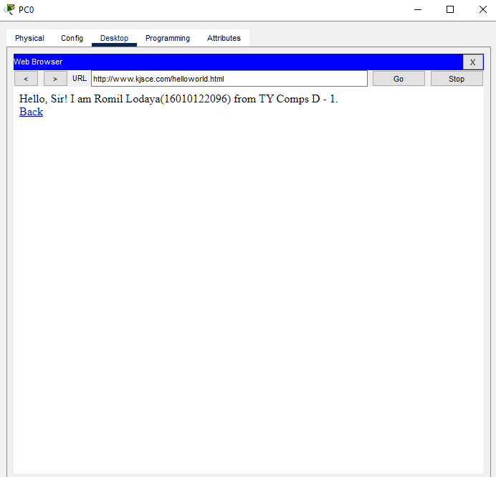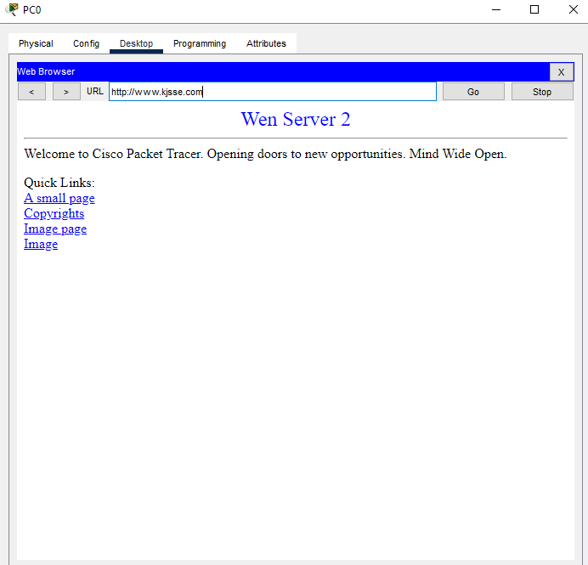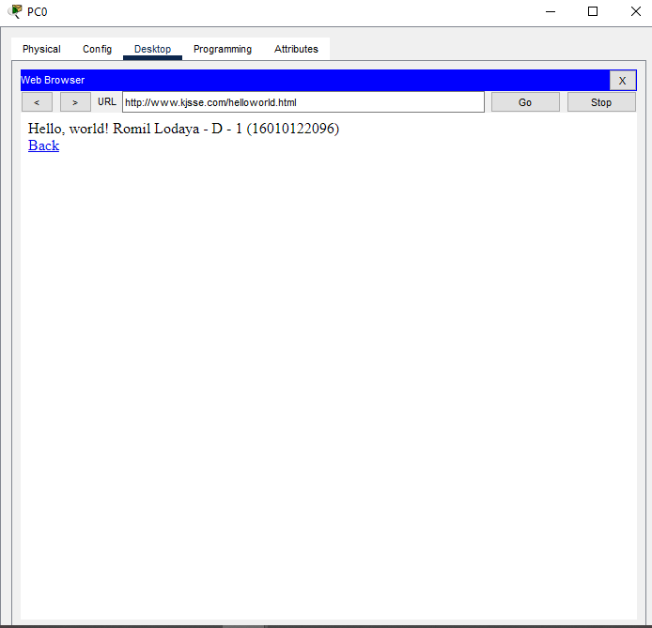

**CONCLUSION:**

We learned abiut different types of servers like DHCP, DNS, WEB SERVER and their configurations.

**Date: ___________ Signature of faculty in-charge**